Hutchinson Police Department
2024 Annual Report
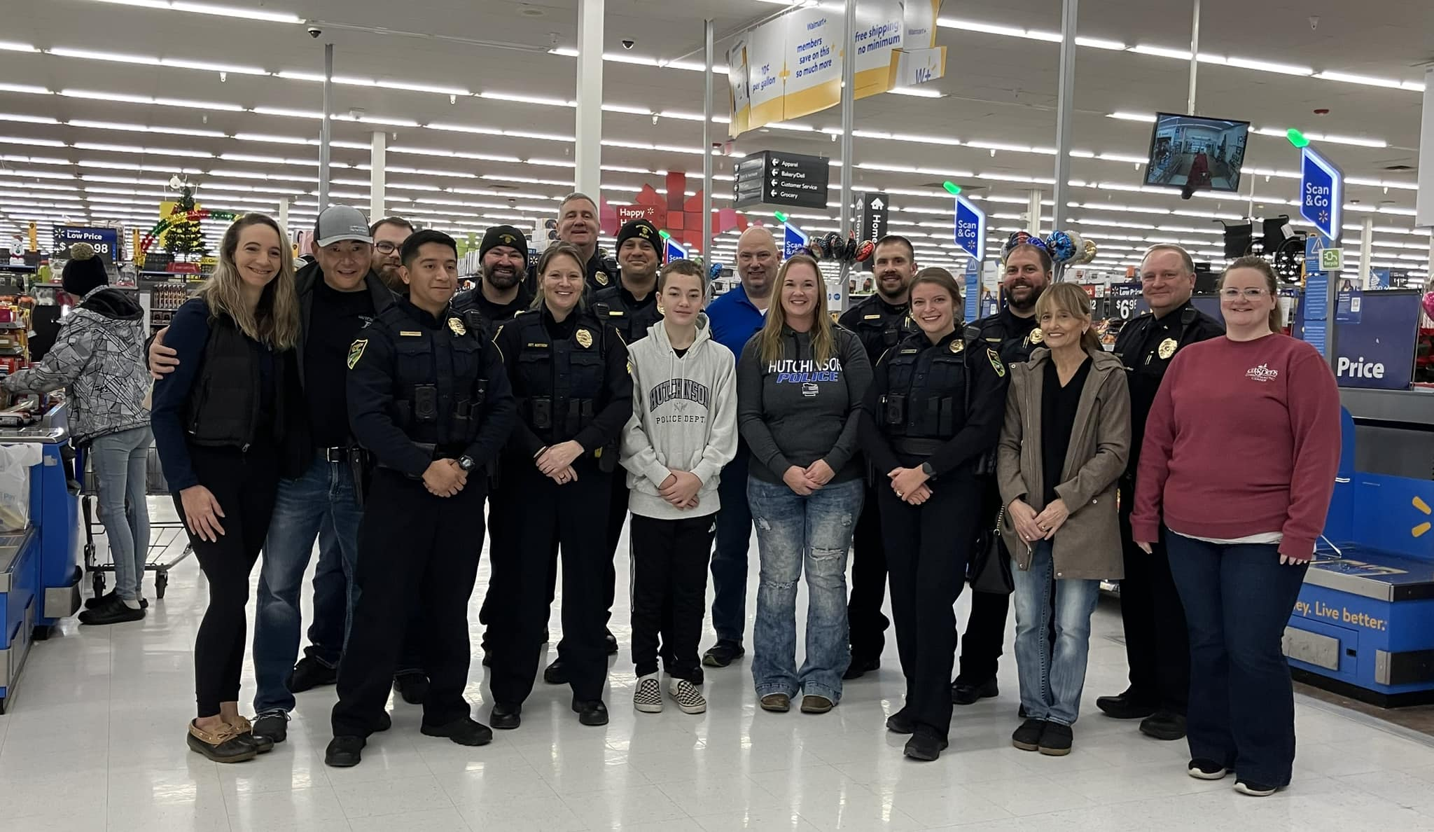

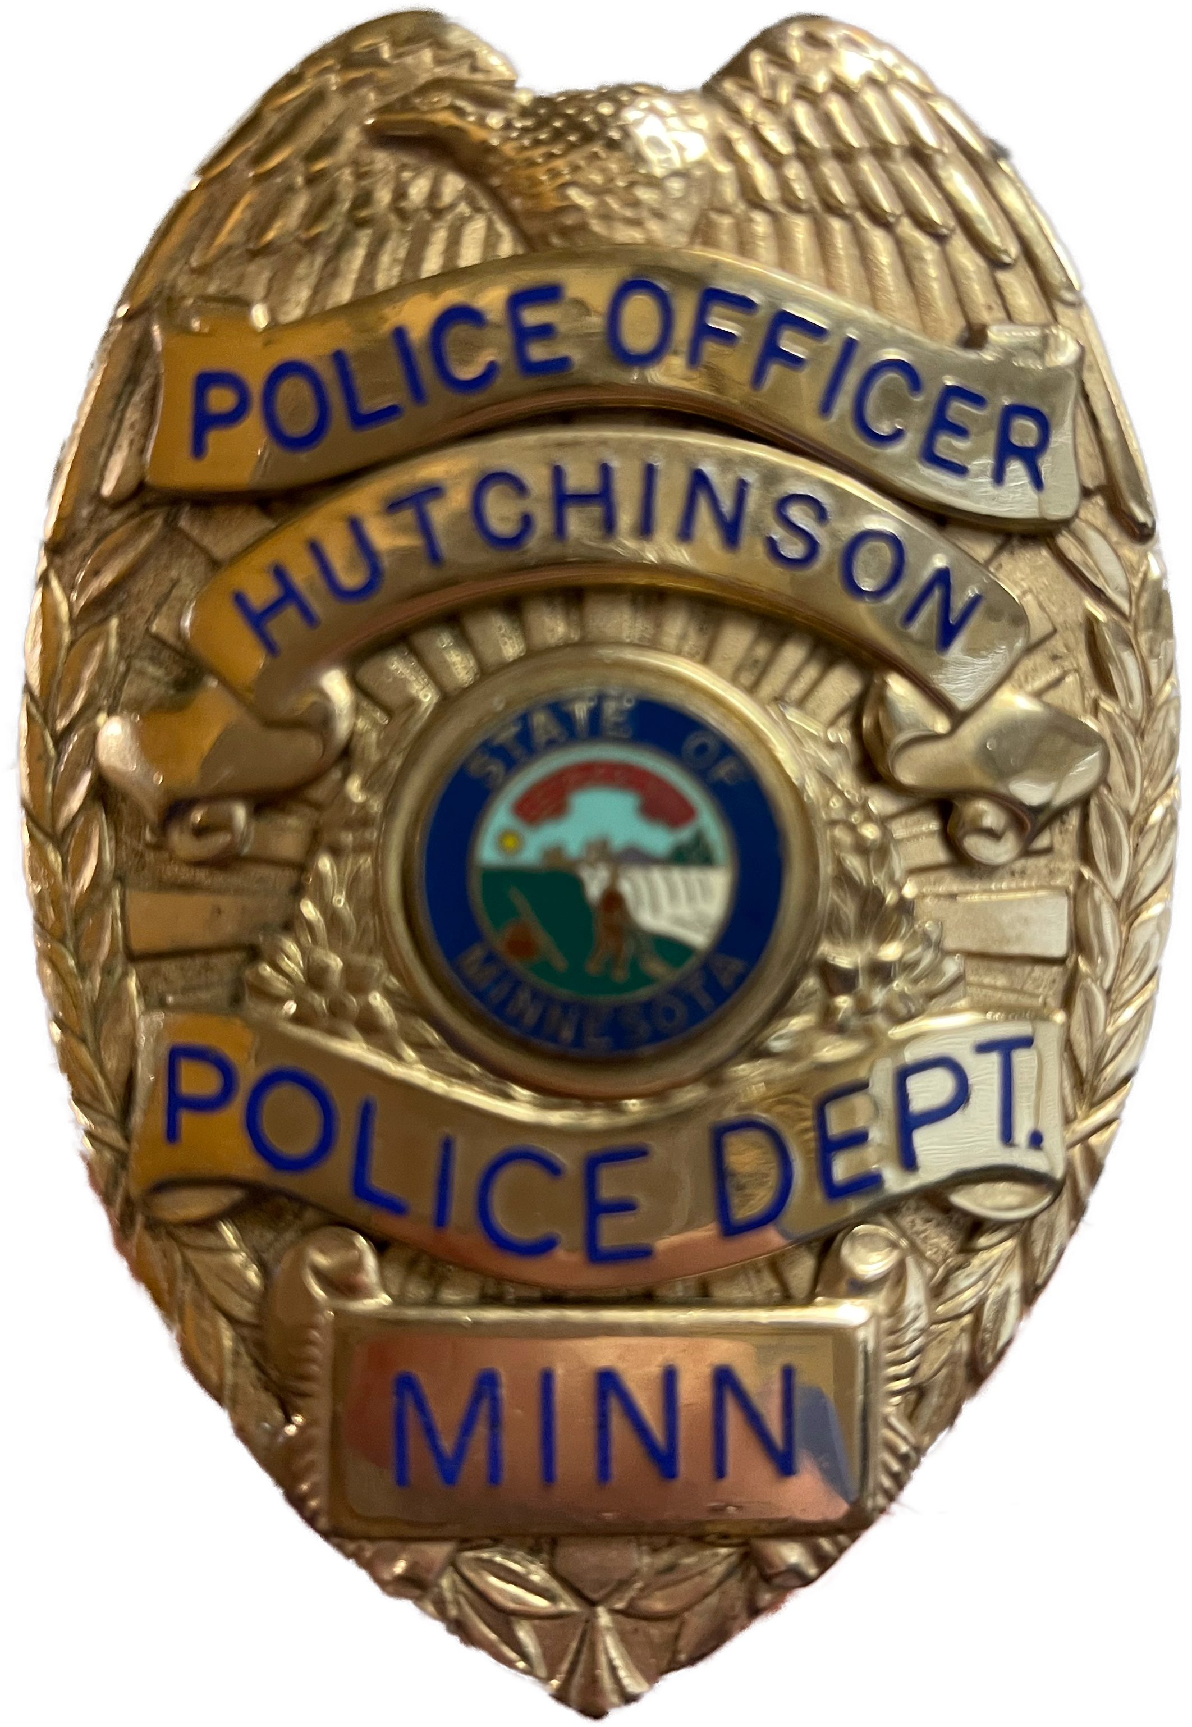
Sworn to Protect, Proud to Serve

Sworn to Protect, Proud to Serve
To facilitate public protection from crime and provide services that enhance the safety and quality of life and the community.

TABLE OF CONTENTS
Message from Chief | 3
About the Department | 4
Group A & B Crime Statistics | 5-7
Patrol | 8
Statistical Information | 9
Training | 10-11
Investigations | 12
SWMDTF | 13
School Resource Officer | 14
Child Protection Officer | 15
SWAT | 16-18
Records Unit/Code Enforcement | 19
Axon Body Camera/Fleet | 20
Citizen's Police Academy | 21

Hutchinson Police Department Contacts
Police Chief
Thomas D. Gifferson………………..tgifferson@hutchinsonmn.gov
Lieutenant
Adam Ament …………………………..aament@hutchinsonmn.gov
Sergeants
Eric Kilian ……………………..……….ekilian@hutcinsonmn.gov
Joseph Nagel …………………..………..jnagel@hutchinsonmn.gov
Ben Erlandson ……………...……...berlandson@hutchinsonmn.gov
Alicia Nortrom …………………...…anortrom@hutchinsonmn.gov
Andrew Erlandson ………………...aerlandson@hutchinsonmn.gov
POLICE DEPARTMENT
214 1st Ave NE – Hutchinson, MN 55350
Phone ……………………………………………. 320-234-4290
Fax ………………………………………...……… 320-587-6647

Website - https://www.ci.hutchinson.mn.us/departmentsfacilities/police-services/

Message from the Chief

Dear Mayor, City Council Members, and Citizens of Hutchinson,
As we close another year, I am honored to present this year-end report to you, reflecting on the work of the Hutchinson Police Department and the progress we’ve made together as a community. I am grateful for the continued support from both the City Council and the citizens we serve.
The core mission of the Hutchinson Police Department is the safety and well-being of our citizens, we continue to work collaboratively with our citizens utilizing crime prevention strategies. We’ve strengthened our community policing efforts, building closer relationships with residents and businesses to address concerns proactively.
We recognize that public trust is vital, and this year we have focused on enhancing communication and partnerships with our community members and always being as transparent as possible. From school outreach programs to hosting events such as National Night Out, we’ve worked to engage citizens in open dialogue. Your involvement is crucial, and we are grateful for your input, which allows us to better serve and protect.
The professional growth of our officers remains a top priority. This year, our department invested in advanced training for all personnel to ensure we are prepared for a wide variety of situations. Our officers have participated in de-escalation training, and crisis intervention courses. This ongoing training ensures that we are equipped to respond to incidents with respect, fairness, and professionalism.
As we enter the new year, we remain committed to continuing our work in strengthening public safety, community partnerships, and officer well-being. We are aware of the challenges that still exist, but I am confident that with your continued support, we can build an even safer and more vibrant Hutchinson.
I would like to express my sincere appreciation to the members of the City Council for your leadership and to the citizens of Hutchinson for your unwavering trust in us. Together we will meet the challenges of the coming year.
Thank you for your continued support, and please do not hesitate to reach out to my office with any concerns or suggestions. We are here to serve.
Sincerely,
Thomas D. Gifferson
Chief of Police
Hutchinson Police Department

About the Department
Department Staff – As of December 31st, 2024
23 Sworn Officers 10 Civilian Staff
1 Police Chief | 1 Child Protection Officer | 4 Police Administrative Specialists
1 Lieutenant | 1 School Liaison Officer | 1 Evidence Technician
4 Patrol Sergeants | 1 Drug Task Force Agent | 1 Police Chaplain
1 Investigative Sergeant | 1 Full-time Community Service Officer
12 Patrol Officers | 3 Part-time Community Service Officer
1 General Investigator

Fleet – As of December 31st, 2024

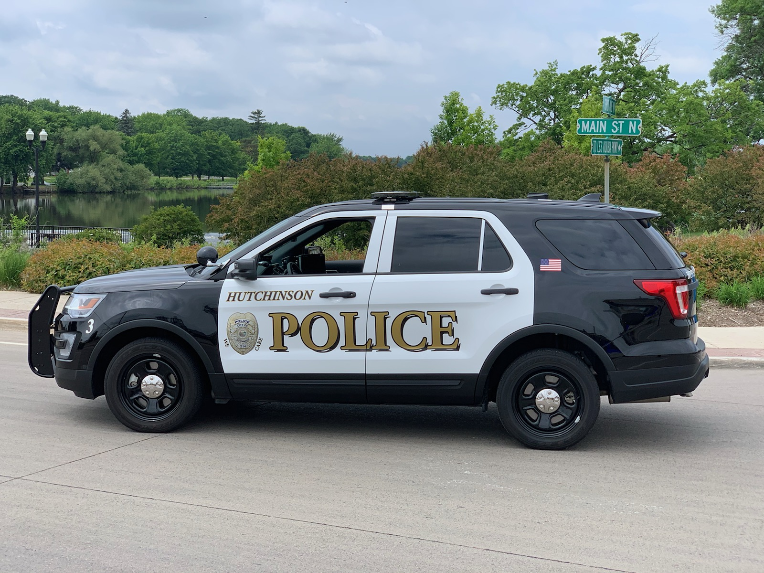

2024 Crime Statistics
In 2021 the Hutchinson Police Department started reporting crime data to the Bureau of Criminal Apprehension (BCA) with National Incident-Based Reporting System (NIBRS). NIBRS is used by law enforcement agencies in the United States for collecting and reporting data on crimes. The BCA then reports all NIBRS statistics to the FBI. Local, state and federal agencies generate NIBRS data from their records management systems. In Group A Offenses there are 24 crime categories with 52 offenses. Data is collected on every incident and arrest in this group. In Group B Offenses, there are 11 offenses with only the arrest information reported in this group.
Key Benefits of NIBRS –
Group A Offenses
- Animal Cruelty
- Arson
- Assault
  - Aggravated Assault
  - Simple Assault
  - Intimidation
- Bribery
- Burglary
- Counterfeiting/Forgery
- Destruction/Damage/Vandalism of Property
- Drug/Narcotic Offenses
  - Drug/Narcotic Violations
  - Drug/Narcotic Equipment Violations
- Embezzlement
- Extortion/Blackmail
- Fraud Offenses
  - False Pretenses/Swindle/Confidence Games
  - Credit Card/Automatic Teller Machine Fraud
  - Impersonation
  - Welfare Fraud
  - Wire Fraud
- Gambling Offenses
  - Betting/Wagering
  - Operating/Promoting/Assisting Gambling
  - Gambling Equipment Violations
  - Sports Tampering
- Homicide Offenses
  - Murder/Non-Negligent Manslaughter
  - Negligent Manslaughter
  - Justifiable Homicide
- Human Trafficking
  - Commercial Sex Acts
  - Involuntary Servitude

- Detailed, high-quality data that provides a more complete and accurate picture of crime.
- Additonal context to understand victimization and offending.
- Standardized data to compare crime across jursiditctions.
- Kidnapping/Abduction
- Larceny/Theft Offenses
  - Pocket Picking
  - Purse Snatching
  - Shoplifting
  - Theft from Building
  - Theft from Coin-Operated Machine or Device
  - Theft from Motor Vehicle
  - Theft of Motor Vehicle Parts or Accessories
  - All Other Larceny
- Motor Vehicle Theft
- Pornography/Obscene Material
- Prostitution Offenses
  - Prostitution
  - Assisting or Promoting Prostitution
  - Purchasing Prostitution
- Robbery
- Sex Offenses (Forcible)
  - Forcible Rape
  - Forcible Sodomy
  - Sexual Assault with An Object
  - Forcible Fondling
- Sex Offenses (Non-Forcible)
  - Incest
  - Statutory
- Stolen Property
- Weapon Law Violations

- Can be used for tactical or strategic analysis at the local, state, and national levels.
Group B Offenses
- Bad Checks (Decommissioned January 2022)
- Curfew/Loitering/Vagrancy Violations
- Disorderly Conduct
- Driving Under the Influence
- Drunkenness (Decommissioned January 2022)
- Family Offenses, Nonviolent
- Liquor Law Violations
- Peeping Tom (Decommissioned January 2022)
- Runaway
- Trespass on Real Property
- All Other Offenses

Patrol
The patrol division of the Hutchinson Police Department is the face of the department. Many community members only ever have contact with a patrol officer, making their impact crucial to the integrity of the department.
Our patrol officers interact with community members when they respond to calls for service, take reports on incidents that have occurred, patrol neighborhoods, enforce traffic laws, and engage at community events. Our patrol officers also conduct criminal investigations by interviewing victims and suspects, reviewing video surveillance, and collecting evidence.
Our patrol officers are very well trained in many areas, including DWI detection and enforcement, mental health crisis, first aid and CPR. They also work closely with businesses on shoplifting and fraud incidents.
The department has twelve full-time officers and two part-time officers assigned to the patrol division. This area is led by four patrol sergeants.

During the 2024 year, officers arrested 34 people for DUI’s. This was 2 more than the previous year. These DUI’s are not all alcohol related, some are the result of drugs. The Hutchinson Police Department forfeited 5 motor vehicles. The 5 vehicles forfeited were from DWI/controlled substances related crimes and fleeing offenses.

In 2024, officers initiated 1620 traffic stops.
There were about 211 less citations and verbal warnings issued in 2024 than 2023. It is important to note that not all citations and verbal warnings issued are from traffic stops.

2024 CRASHES
Property Damage Crashes | 172
Personal Injury Crashes | 13
Hit and Run Crashes | 37

In 2024, officers responded to 360 crashes. 138 of those crashes were minor and didn’t require officers to write a state crash report. There were 172 property damage crashes and 13 personal injury crashes. Of the 364 crashes, 37 of them were hit and runs.
Statistical Information

The Hutchinson Police Department responds to calls-for-service twenty-four hours a day and seven days a week. The busiest time frames for the officers in 2024 were 10am and 4pm.

2024 started out average and slowly increased in spring until fall. February was the lowest month for calls-for-service while October was the highest month.

Friday was the busiest day of the week for calls for service for the Hutchinson Police Department in 2024. Monday, Tuesday and Wednesday were all very similar in calls for service. Sunday was slowest day of the week by 1233 calls for service.

Training
Each year the staff of the Hutchinson Police Department participate in various trainings. These trainings allow for staff to stay updated on all current policies, information, and technology within law enforcement. The Minnesota Board of Peace Officers Standards and Training (POST) requires officers to complete forty-eight hours of continuing education every three years in order to renew their POST license.

Emergency Vehicle Operations and Police Pursuits (EVOC)
Officers shall demonstrate the knowledge and skill needed to reduce criminal and civil liability when involved in emergency and non-emergency vehicle operations mode. This training must be designed to give officers both skill and decision-making ability so that emergency vehicle operations can be resolved safely and successfully. This will be accomplished with a minimum of eight hours of training, which will include a minimum of four hours of in-vehicle operation. Simulators may be used in addition to in-vehicle and classroom training but will not be used to replace the minimum four hours of in-vehicle training. It is recommended that simulator training be used for decision making training.

Field Training
The field training process is a 16-week, 640-hour requirement for all new Hutchinson Police Department officer hires. New officers must show progression in job performance and complete all four phases to pass the field training process and become an independent officer.

Patrol Online (PATROL)
To help cities reduce losses related to police liability, LMCIT has developed PATROL—Peace Officer Accredited Training Online. While PATROL delivers twelve new POST-accredited courses per year, subscribers can earn more than forty POST credits per year when they also take PATROL training on POST mandates for Use of Force and Crisis Intervention and Mental Illness Crisis; Conflict Management and Mediation; Implicit Bias, and Community Diversity and Cultural Differences. PATROL helps officers stay current on Minnesota legal issues and is based on Minnesota case law. Content is developed with input from police liability experts, insurance defense attorneys, and local law enforcement agencies. Each month, a new course is available for one POST credit.

Additional Training for 2024:
- Initial Response to Child Deaths
- BCA Single Certification
- Critical Issues - Duty to Intervene & Render Aid & Marijuana & Policing
- New Firearms Laws & Universal Background Checks
- Mental Health Part 1-5
- True North Constitutional Policing
- Use of Force Part 1-3
- Crimes Motivated by Bias
- EMS Refresher
- Firearms - Inclement Weather, Low Light, 2 Qualifications
- Extreme Risk Protection Orders
- Active Threat/Critical Incident (Practical) (Classroom)
- Car Seat Basics for Law Enforcement
- 2024 League of MN Cities Workshop
- Protecting & Serving the LGBTQ+ Community
- Use of Force/Defensive Tactics (practical)
- Duty to Intercede
- DWI - SFST Update
- 2024 Legislative Update
- Employee Misconduct & Discipline
- Critical Issues - Firearms Restoration/Mental Health/ERPO's
- Take Action: Make the R.I.G.H.T. Choice to Intervene
- Ethics & Integrity in Supervision
- Minnesota Crisis Intervention Team Training

- DMT Re-Certification
- Persuasion & De-escalation
- Transport (72-Hour) Holds
- Use of Force Tactics Instructor Certification
- Implicit Bias 1-2
- Consent Searches
- Development, Management, & Control of Drug Informants
- Interviewing Children with Disabilities and Use of Media
- Peer Support Team Training
- Less Lethal Instructor Development
- SOTA Annual Training Conference
- 2024 BCA Criminal Justice Information Conference
- Best Practices in Mental Health Crisis Response
- Procedural Justice & Police Legitimacy
- Serving Those with Autism Spectrum Disorder
- Predatory Offender Registration Training
- Driving, Operation & Recovery Training with Armored Vehicles
- Vehicle Impounds & Inventories
- 2024 MN Chiefs Association Conference
- Diversity with Emphasis on Implicit Bias
- Peak Performance for Protectors
- Disorderly Conduct and Obstruction
- FTO Certification
- Responsible Alcohol Service - Train the Trainer

Investigations
The Hutchinson Police Department Investigations units is comprised of five licensed officers and one Evidence Technician. This unit is supervised by a Sergeant. The four officer positions within the investigation’s unit are the School Resource Officer, Drug Task Force Officer, Juvenile/Child Protection Officer, and General Investigator. All of these positions are rotating assignments which allows all officers to gain valuable investigative experience.

The Investigations unit offers valuable support to the patrol officers by following up on investigations that require more time than the patrol officers can give to an incident. The investigations unit is able to spend more time gathering information from witnesses, suspects, and the courts to help solve the crime.

The General Investigator position assists the patrol staff with more complex investigations. The General Investigator also works with social services and specializes in working with vulnerable adult cases.


The Evidence Technician position maintains the collection of all the evidence and property entered into the evidence/property room by the officers. This position also sends evidence to the MN BCA for lab testing for DUI’s, drugs, and fingerprinting. The Evidence Technician also properly stores and preserves all evidence for future investigations and past investigations.

Southwest Metro Drug Task Force Officer (SWMDTF)
The Drug Task Force position is with the Southwest Metro Drug Task Force. This position works with other counties and cities in drug related incidences to get as many illicit drugs and guns off the street as possible.
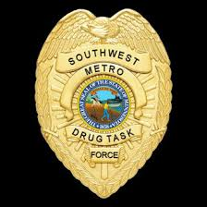

The breakdown of 238 SWMDTF investigations in 2024 are shown here by city.

School Resource Officer

The Hutchinson Police Department is contracted with the Hutchinson School District for the School Resource Officer. The School Resource Officer position is a four-year rotating position within the police department. The School Resource officer works closely with the Hutchinson High School and Hutchinson Middle School staff and students.

The School Resource Officer has an office within the Hutchinson High School and is in the school buildings daily from 7am to 3pm. The relationship the School Resource Officer builds with the staff and students is a great asset for the Hutchinson School District and the Hutchinson Police Department.

There was a total of 231 calls for service at all the schools in the district in 2024. There were 110 incidents at the High School, 56 at the Middle School, 25 at Park Elementary, 30 at Tiger Elementary and 10 at West Elementary.

Child Protection Officer
The Child Protection Officer is a position that works closely with McLeod County Social Services on a daily basis. This is a close relationship that we have determined works best to help children and families in the City of Hutchinson. The Child Protection Officer is a five-year position in the Investigative Unit.

The Child Protection Officer also works closely with the BCA and the predatory offender compliance program. This position assures that all the predatory offenders within the city of Hutchinson remain compliant with the BCA.


SWAT
The Hutchinson Police Department’s Special Response Team (SRT) partners with the McLeod County Sheriff Department’s Emergency Response Unit (ERU) to provide officers for tactical response services. The joint tactical team operates under the team name, Crow River SWAT. Officers selected to the team receive advanced training to respond to situations needing high-risk warrant services, crowd control, hostage negotiation, snipers, and critical incidents.
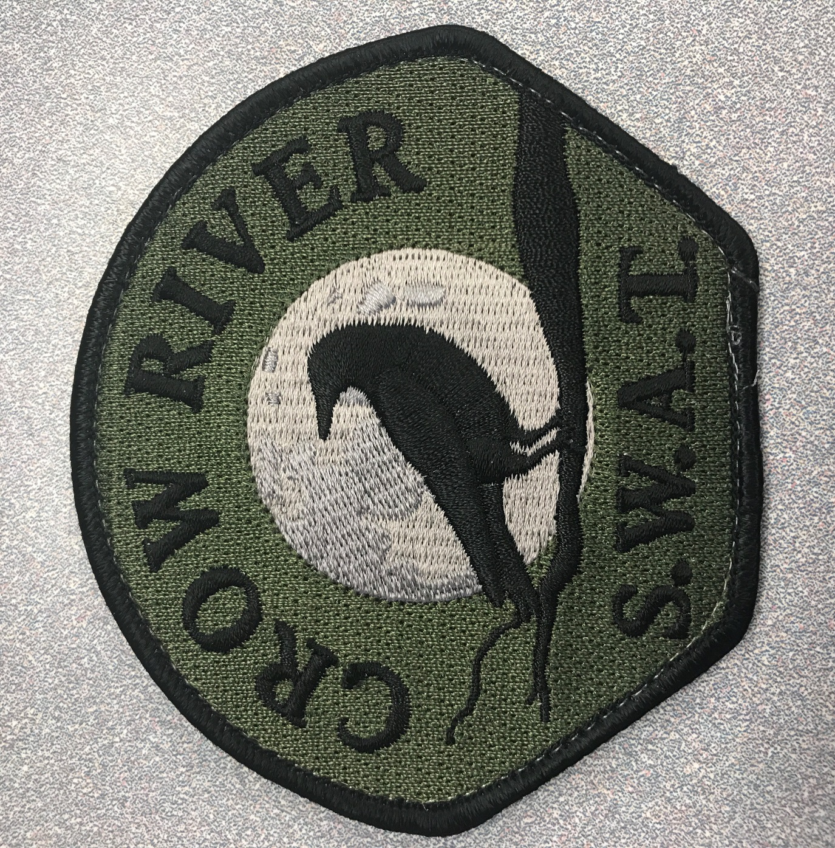

The Hutchinson Police Department’s SRT includes highly trained officers who use specialized weapons and tactics to handle high-risk situations beyond the scope of the patrol and investigative divisions. Examples of situations for which the SWAT team would be used include high-risk arrests and warrants, barricaded and armed suspects, hostage rescue, crowd control, dignitary protection, and disaster response. The team’s primary goal is to resolve situations as safely as possible for everyone involved.

Crow River SWAT has approximately ten officers from each department on the team. The team also includes a separate crisis negotiation team that works with the tactical team to safely resolve these critical incidents. Officers selected and assigned to the team train one day per month on skills and equipment special to the tactical team’s mission. In order to be selected, officers need to have been an officer for a minimum of two years, pass the physical fitness assessment, show proficiency with firearms and defensive tactics skills, and have exhibited sound emergency response skills as a patrol officer.

SWAT YEAR END STATS:
Callouts:
There were no callouts in 2024 where Crow River SWAT was requested as a team in whole.

Close Calls or Near Misses (Personnel or CRS Equipment Used):
ICR 24006120 (HPD – Threats of Violence & Tampering w/ witness)
ICR 24012763 (HPD – Weapons and Threats of Violence)
ICR 24007077 (MCSO – Weapons Call)
ICR 24001511 (MCSO – Disturbance)
ICR 24001956 (WPD – Domestic/Weapons/Fleeing by other means)
Agency Assist (Minneapolis/Meeker/McLeod/HPD/SWMDTF) – Pursuit through county with an attempted murder and murder in Kandiyohi County.

2024 Statistics for Equipment/Negotiations requested:
- ARV (Bearcat – MCSO) was used 4 times
- Drones (MCSO) was used 9 times
- HPD Negotiator was called in for negotiations for an incident in Lester Prairie ICR # 24001511. Negotiations were not used once there as the situation was resolved.

2024 Equipment Upgrades:
MATV Rescue Vehicle (HPD)
Mobile Command Post (MCSO)
Shatterballs (MCSO)
RAT-Traps (HPD)
Sniper Rifle (MCSO)
Axon Body 4 Cameras with “Live,” Feature

2024 Crow River SWAT Training:
The Crow River SWAT trained 10 out of 12 months in 2024, missing the month of March due to McLeod County Active Shooter Training and then in December due to staffing, sicknesses, and road/weather conditions.
The synopsis of each month of trainings can be included if requested. Highlights from 2024 Training is as follows:
- Annandale Shoot house
- Vacant House in Glencoe, Mn
- Vacant property on North High Drive used several times
- Full Callout scenario-based training on North High Drive utilizing all groups within Crow River SWAT.

2024 Individual Training:
Team Leader Development
Basic SWAT
Active Shooter Instructor
Vehicle Suppression Training (Wright County Training)
Basic Sniper
SOTA Conference

Records Units
Public Records Request | 716
Permit to Purchase/Conceal Carry Background Requests from Other Agencies | 385
Other Agency Background Requests (Social Services, Probation, Housing and Redevelopment Authority) | 169

The records units for the Hutchinson Police Department consists of four full-time employees. The records unit has a variety of tasks and assists the Chief, Lieutenant, Investigations, and patrol officers with daily duties. The records unit answers phone calls from the public and assists the citizens who come into the lobby of the police department. Citizens come into the lobby for a wide variety of reasons, but most common are records requests, animal licenses, and fingerprinting.
The records unit is an intricate and vital part of the police department. They ensure reports are processed properly and sent to the City of Hutchinson and McLeod County Attorneys for charges on offenders. They handle the dissemination of officer’s reports to social services, probation, and citizens who request data. They also complete public data requests, permit to purchase handgun applications, monthly statistical data reports to the State of MN, the billing for the police department, the annual police report, and ensure everyone in the police department is current on their required training through the BCA.
Code Enforcement – Nuisance Property
The Hutchinson Police Department has a Code Enforcement Officer who is assigned to all the nuisance properties in the City of Hutchinson. The Code Enforcement Officer is a three-year rotating position. This position maintains the files and speaks to the property owners to try and get the properties in compliance with City of Hutchinson Ordinances. The Code Enforcement Officer also does random checks on these properties to try and determine if work is being performed to get these properties in compliance. If the properties are brought into compliance, the officer will close out the report. If the properties are not brought into compliance within the agreed amount of time, the Code Enforcement Officer then issues a citation or sends a report to the City of Hutchinson Attorney requesting charges against the owner.

Axon Body Cameras/Fleet
The Hutchinson Police Department implemented Axon body cameras in 2016 with a donation from a local area business. This was a great push in getting AXON body cameras for every officer in the department. Hutchinson Police Department policy states that officers must have their body cameras recording during any interaction they are dispatched to or come upon.

 | Total Uploads
Number of Videos | 18539.0
Hours of Videos | 4066.88
GB of Videos | 7445.5
Label | Active AXON Evidence
Number of Active Videos | 10017.0
Hours of Active Videos | 2601.57
GB of Active Videos | 4733.79
Label | Average Per Day
Number of Videos Uploaded | 50.65
Hours of Video Uploaded | 11.11
GB of Video Uploaded | 20.34

Categories | Files | GB | % Files | % GB
Report | 15629 | 3882.62728 | 76.03502797 | 73.98263462
Traffic Stops | 3558 | 939.1115061 | 17.30965702 | 17.89456943
No Action Take | 1208 | 374.3801124 | 5.876915592 | 7.133733182
Accidental Recording | 96 | 19.36257623 | 0.46703965 | 0.36894976
Uncategorized | 25 | 10.94556823 | 0.121624909 | 0.208565468
Permanent Retention (Admin Use Only) | 21 | 8.101860927 | 0.102164923 | 0.154379232
Training | 10 | 11.09146988 | 0.048649964 | 0.211345593
Administrative (Supervisor Only) | 5 | 1.117935178 | 0.024324982 | 0.021302016
Critical Incident | 2 | 0.519065682 | 0.009729993 | 0.009890686
Officer Injury | 1 | 0.767787229 | 0.004864996 | 0.014630022

Citizens Police Academy
The original concept of the Citizen Police Academy (CPA) came from Great Britain, where the United Kingdom (UK) Constabulary designed a program to give citizens an overview of British law enforcement operations. Known as “police night school” when it began in 1977, the program was an immediate success.
The Hutchinson Citizen Police Academy (CPA) is a community oriented policing program that is conducted once a year in order to accomplish three goals:
- To allow citizens of Hutchinson to meet the men and women who serve them.
- To educate in the “how’s and why’s” of law enforcement.
- To provide Hutchinson Police Officers the opportunity to meet and hear from the citizens they serve.
The Hutchinson Citizen’s Police Academy is ten weeks long and ran from November 2023 to January 2024. CPA Participants are given a realistic view of the Hutchinson Police Department. A wide variety of topics are discussed: department history, organizational structure, police officer selection and training, communications/records, tools and equipment, officer survival, patrol procedures, DUI and traffic enforcement, use of force or deadly force, arrest procedures, handling of traffic accidents and criminal investigations, gangs, pursuit driving, chaplain program, crime prevention, critical incidents, youth issues and liaisons, reserves/volunteer services, and a myriad of other law enforcement subjects. In addition, opportunities to tour the police department and ride along with a police officer are provided to CPA students. Our last academy was in 2021 and had six community members attend.


